Keegan Smith

Data Structures: HW1

6/11/2023

1. Assume each expression listed below represents the execution time of a program. Express the order of magnitude for each time using big O notation.

$T\left(n\right)=n^{2}+10n*\log_{2}n+3220$

$$f\left(n\right)=O\left(n^{2}\right)$$

$T\left(n\right)={9n}^{4}+3^{n}$

$$f\left(n\right)=O\left(3^{n}\right)$$

$T\left(n\right)=\frac{n^{3}-2}{n^{2}+4}+16n$

$$f\left(n\right)=O(n)$$

$T\left(n\right)=n\left(n+3\left(n+2\left(n+1\right)\right)\right)$

$$T\left(n\right)=n(n+3(n+2n+2))$$

$T\left(n\right)=n(n+3n+6n+6)$

$T\left(n\right)=n^{2}+3n^{2}+6n^{2}+6n$

$$T\left(n\right)=10n^{2}+6n$$

$f\left(n\right)=O(n^{2})$

1. ) For each of the code segments below, determine an equation for the worst-case computing time T(n) (expressed as a function of n, i.e. 2n + 4) and the order of magnitude (expressed using big O notation, i.e. O(n)). Note that:
   * Each executable line of code is numbered so you can refer to it by number if necessary.
   * A for loop may be treated as a single statement, not three separate statements

$T\left(n\right)=c1+c2+\left(c3*n\right)+\left(c4*n\right)+c5+\left(c6*n\right)+\left(c7*n\right)+c8+\left(c9*n\right)+\left(c10*n\right)= O\left(n\right)$

Constant due to the linear nature of the for loops and if statements.

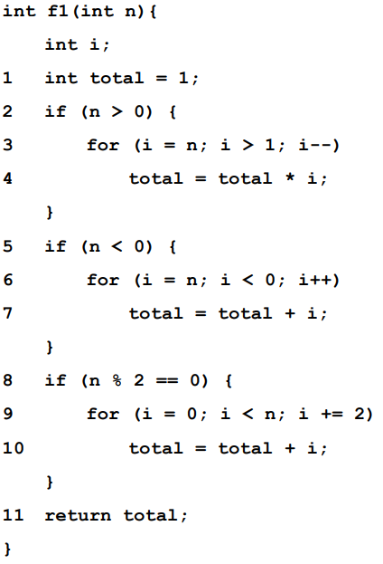

$f\left(n\right)=\left(c1*n\right)+\left(c2*n\right)+\left(c3*n*logn\right)+\left(c4*n*logn\right)= O(logn)$

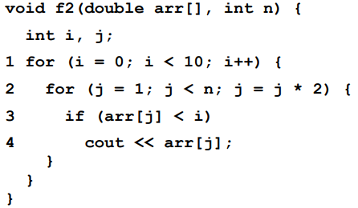

Because of the nested for loop, you got O(n \* n) and the if statement provides O(n), so the resultant would be O(n2).



For lines 1 and two, f(n) = O(n) because we are just saving things into the vector. (linearly)

For line 3, 4, 5 f(n) = O(n) as well because they are linear actions.

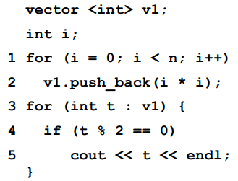



$f\left(n\right)=\left(c1*n\right)+\left(c2*2n*2n\right)+\left(c3*2n*2n\right)+\left(c4*2n*2n\right)+\left(c5*2n*2n\right)+\left(c6*2n*2n\right)=O(n^{2})$

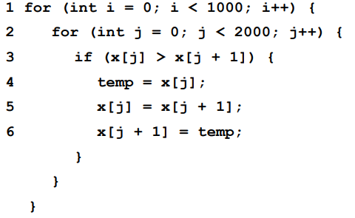because of the nested for loop. The if statement would provide a O(n).